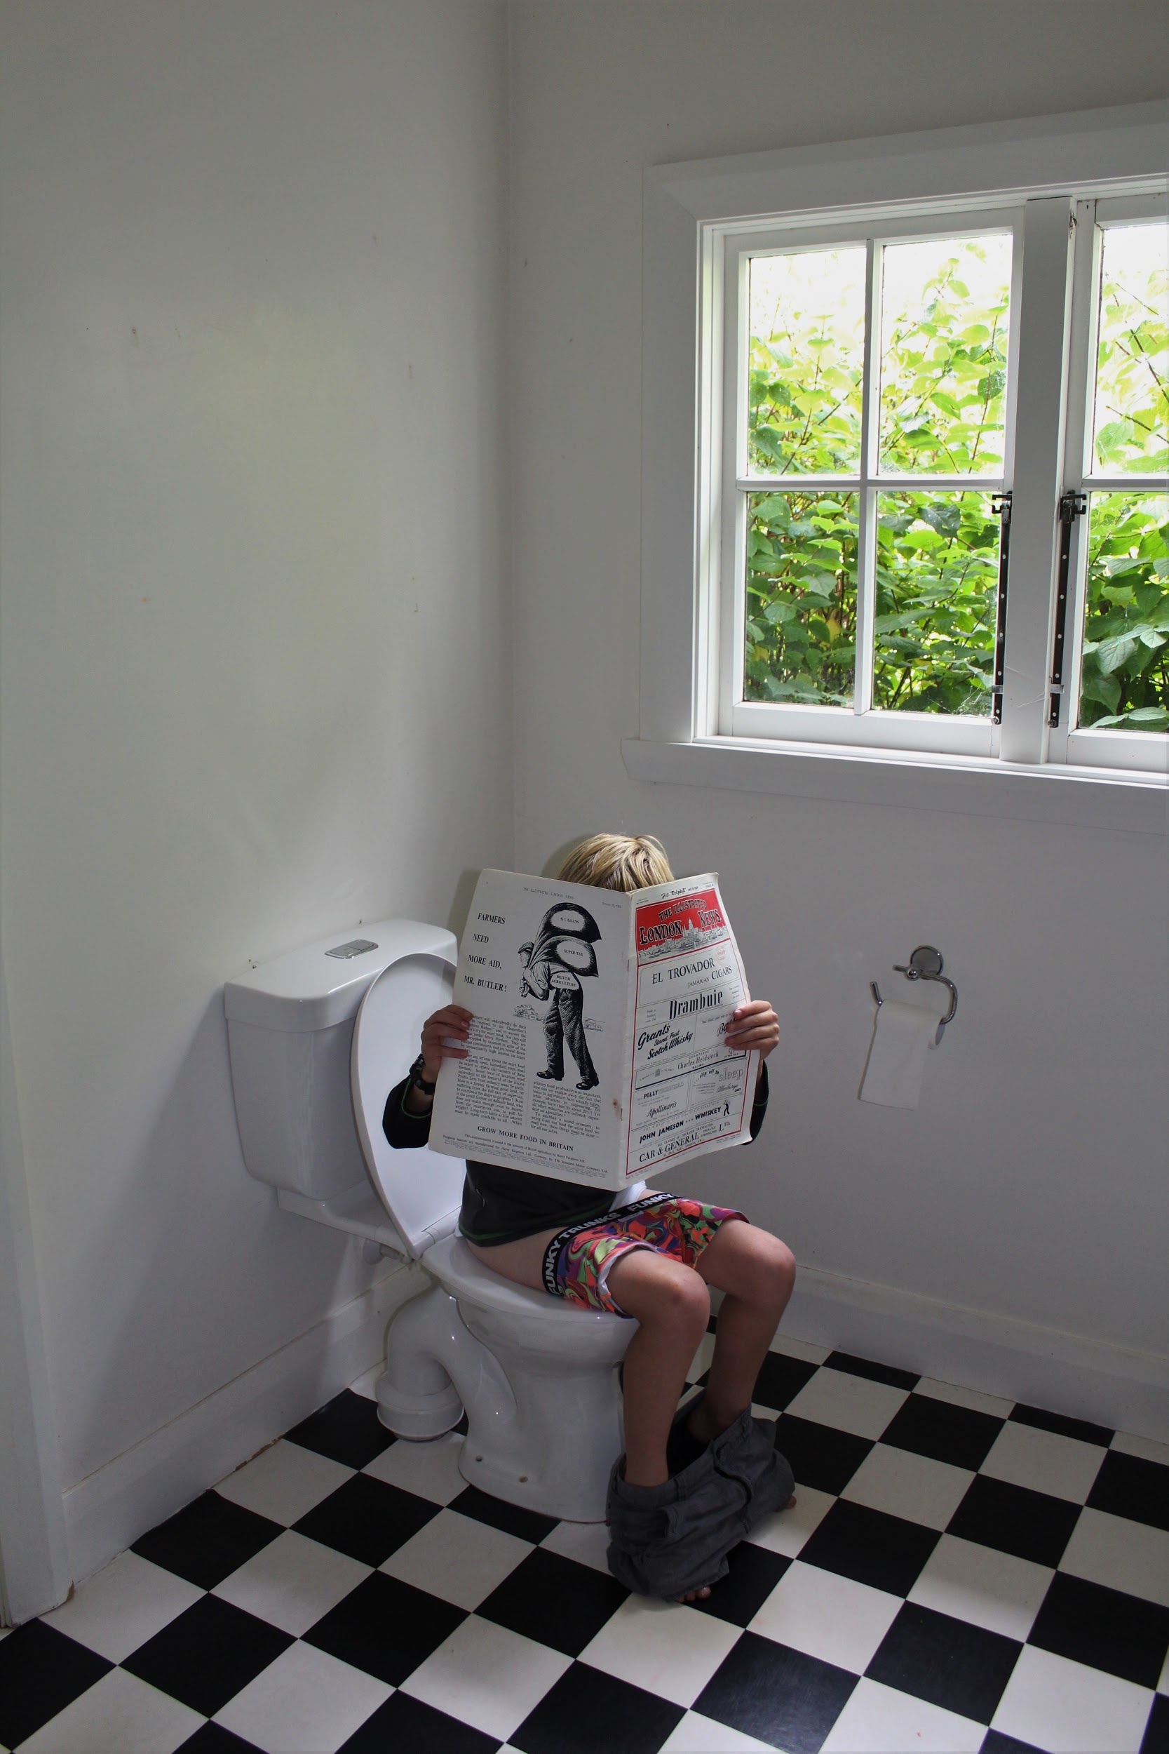

DEATH OF MAGAZINE

While doing my business, I sit staring at my phone. Eyes straining, neck dropped as low as possible to find out some daily un-useful information. My face illuminated with the glow of the screen, I will probably have frown lines before I turn 25. Before this digital takeover, I would have had one hundred and forty-four pages of pure goodness to soak myself into. Images which have been staged, articles that give me a whole sense of what I can do to make a change. I would've read this cover to cover at least twelve times, just because well, you sitting there yelling at me to have a quick scan. I might as well, I have nothing else better to keep me occupied while my metabolism does its thing.

In 1731, an Englishman named Edward Cave published The Gentleman’s Magazine. His publication of The Gentleman’s Magazine included stories, poems and essays. Edward probably did not intend to be the first publisher of this so called ‘magazine’, but the guy also invented the name too.

In 1842, the first illustrated magazine formed. This was after realizing that colorful sketches and illustrations contributed to magazine sales. A lad called Herbert Ingram decided ‘Hey! let's also put this in the magazine!’. The weekly news was now filled with arts and woodcut designs to captivate an audience. Shortly after the first publication of The Illustrated London News, the birth of photographs in magazines became a trendy thing.

Magazines have a hell of a lot of history and these guys didn't just create it for a thing of the past. They created it for culture. We are the generation of killing off the traditions, ‘the death of’.

I have always been a magazine consumer. Only going on grocery shopping trips at the start of every month. Somehow it always seems to slip into the trolley. But as we que, I notice people pick them up, do the backwards-starting flick through and then put it down. Maybe it's a money factor, or maybe it’s the digital age. Nearly every magazine has a web page which includes the articles that are also in the paper-back copies sold at ‘ya local’. Why pay pocket money for a paper future dust collector when you can access it at a touch of a finger?

Tearaway is a New Zealand youth-run magazine. Created by a bunch of 13-24 year old writers, photographers, film-makers, designers, illustrators, website wizards and social media experts. They call these humans ‘The Mavericks’. Tearaway began in 1986, by the-now editor Rain Francis’ ‘rents. Dedicating the magazine to the youth of NZ, to keep scallywags under the radar and reading something awesome. Tearaway has recently turned away from the classic paper form to digital (e-magazine). WHY? Milk interviews editor Rain Francis to find out about this rather large decision Tearaway had to cross.

**So tell me about Tearaway and why Tearaway chose to turn to e-mag? Rather than a paper form?**

**Why are we no longer in print? Mostly, the boring answer…. money! As an independent operator, when I took on the business from the previous owners - a large publication company - I decided to focus on building Tearaway’s digital presence first. The overheads for this as opposed to print are so much more manageable. But we would love to return to print in the future!  
  
  
What impact has the e-mag made to Tearaway? Has it increased readers? (If so, how do you keep track?)**

**Although Tearaway has a long history and is a well-known name, in many ways we started almost from scratch when we went 100% digital. Unfortunately I don’t have readership figures from when Tearaway was in print, but our numbers have increased steadily since the digital format was launched at the end of 2014. We monitor this through a combination of Google Analytics, MailChimp and social media.**

**Tell me how you guys chose 'The Mavericks'? And why did you decide to use youth to run the magazine?**

**Anyone aged 13-24 can apply to be a Maverick. They are required to send in samples of their work and if it’s up to publication scratch or we can see the potential for it to be, they have a place on our team. Tearaway is a place to get media experience and to find your own voice, so we don’t expect our Mavericks to be perfect when they apply - we mentor them to improve their skills and professionalism as they work with us. Our content is FOR youth, so it makes sense that it is BY youth!  
  
  
How do you think the magazine industry will evolve in 15-20 years’ time? Do you think it will all be digital?**

**I think there will always be people who prefer print over digital (and vice versa), so there’ll always be a market for it in some way. And now that we’re starting to see things like tree-less paper, there’ll be other environmentally-friendly ways to produce print. 20 years is an extremely long time in terms of how quickly things are progressing technologically, so I have no idea what it will look like. 20 years ago, mobile phones and the internet were only just becoming a thing. I remember literally cutting and pasting pieces of text together to create pages (IRL - not on a computer!) … and I’m not even that old!  
  
How do you promote Tearaway to young readers?**

**Social media, EDMs (subscriptions - they’re free!) and through partnerships with like-minded companies. We’d love to have our Mavericks go into schools too - that’s next!!**

Video killed the radio star, didn't he? So, digital killed the magazine star. Or are we, the youth contributing? Are we the problems and witnesses to the soon-to-be paperless future?

David Carson is considered to be one of the world's most influential graphic designers. Being a lead designer for Transworld Skateboarding magazine, Beach Culture and of course, Ray Gun Magazine. Even with such a heavy involvement to the magazine scene, Carson is no fan of the electronics taking over magazine. “People noticed it, loved it and hated it, and it happened at the time that computers were seriously being used like magazines”. Don’t get me wrong, computers are the right hand to magazine production, but with everything already there on the screen, what is the point in forking out a fortune to get it printed?

Paper, it's timeless, it’s memorable, it’s all a heart-warming experience. From the colour pallets which influence your next clothing choice, to the crisp square images with that minimalistic touch. You fold down the top corner of the page to mark that influential photograph, it’s a collector's item for some.

No wonder eyesight is progressively getting worse, not just with old age. It's the digital age. Unfortunately, with magazines we cannot make the font larger if we wish. You have to physically read. Yea, read. Read about those articles that you never thought you would know, but knew. You could possibly call it brain training because, Oh! The information you will learn in under five minutes!

But then again, thank you! This is a REAL magazine which you are reading about REAL magazines! So, I am not targeting you, I’m targeting the buddies around us. The ones who have never owned a magazine. Who have never smelt that fresh (almost plastic-like) scent and felt a little itch of excitement. The people who do not grab a magazine off the shelf while sitting in a cafe sipping a vanilla latte. This is for them.